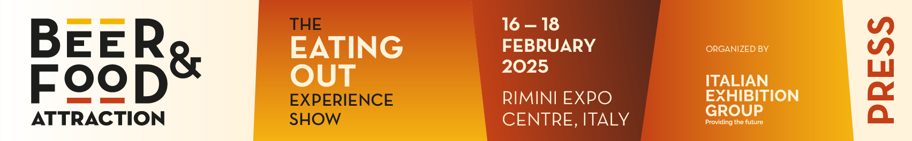

Press release no. 1
(English translation)

BEER&FOOD ATTRACTION GROWS FURTHER
AND CONQUERS THE BAR INDUSTRY WITH THE MIXOLOGY VILLAGE

- At Rimini Expo Centre from 16th to 18th February 2025, the 10th edition of the leading event for the bar industry and eating out in conjunction with the 14th Italgrob International Horeca Meeting
- The 3rd edition of Mixology Circus will be back and enlarged with the Mixology Village dedicated to spirit labels and bartending equipment
- The Beverage sector will open its doors to sparkling wines with the Sparkling&Mix area
- At the same time, the 7th edition of BBTech Expo specifically for beer and beverage processing and bottling technologies

beerandfoodattraction.it
bbtechexpo.it

Rimini, 31st July 2024 — An established reference point for the eating-out sector, Beer&Food Attraction is preparing for a 2025 edition that will dominate the national Beverage & Bar Industry scene. Alongside Italian and international brewing excellence (craft and mainstream) and the most complete offer from the beverage world, from mineral water to fruit juices, soft drinks and spirits, the Mixology area will be larger with the introduction of new categories such as sparkling wines. Eating out at Beer&Food Attraction will also be represented by a varied Food proposal with ready-to-eat products for the casual dining channel.

NEW ENTRIES FOR 2025: MIXOLOGY VILLAGE AND SPARKLING&MIX
Beer&Food Attraction will also become the stage for the SuperHoreca universe thanks to an enhancement of the offer revolving around the ritual of the aperitif. The art of mixing will therefore find its highest expression in the Mixology Village, which will showcase companies producing spirits and small bartending equipment, as well as incorporating the third edition of Mixology Circus, a reference event for the spirits world. Another new highlight will be Sparkling&Mix, the exhibition area where sparkling wines for the cocktail world will emerge.

HORECA’S NEW FRONTIERS ON STAGE IN RIMINI
The 10th edition of di Beer&Food Attraction – The Eating Out Experience Show, organised by Italian Exhibition Group, will be held at Rimini Expo Centre from 16th to 18th February 2025 at the same time as the 7th edition of BBTech expo, the Exhibition for beer and beverage processing and packaging technologies, raw materials and accessories, and the 14th edition of the Italgrob International Horeca Meeting, attended by Horeca supply chain operators.
Thanks to collaboration between ITA -Italian Trade Agency, the Ministry of Foreign Affairs and International Cooperation and the network of Italian Exhibition Group regional advisors, over 130 buyers from 40 countries have already confirmed their attendance.
Beer&FoodAttraction will bring all the Horeca supply chains to the Expo Centre where partnerships with the main sector realities will take shape, including Italgrob – Italian Federation of Horeca Distributors, FIC – Federation of Italian Chefs, Assobirra, Unionbirrai, World Association of Chefs Societies. The Food Park will be further enriched with ready-to-eat products to cater for casual dining consumption and trends, a fast-growing sector that combines quick service with quality culinary proposals. The widest range of frozen food, pizza bases, burgers and meats, appetisers, snacks, sauces, vegan and street food will be on show. Furthermore, the Beverage project will become even larger by intercepting the sector’s most fashionable categories, such as No Alcohol and Low Alcohol products that are increasingly attracting Millennials and Generation Z.

EVENTS
The show will host a full programme of events and professional training masterclasses to chart the new course for the future of eating out. Training meetings on beer and technology will be held in the BEER&TECH Arena. Major competitions will be back, such as the Beer of the Year Competition and the Italian Craft Beer Conference organised by Unionbirrai. The Food arenas, on the other hand, will be busy with the Italian Cookery Championships organised by the Federation of Italian Chefs (FIC) and the Global Chefs Challenge European Gran Prix 2025, the European haute cuisine selection event in preparation for the Worldchefs world championship circuit.

SPACE FOR IDEAS WITH THE INNOVATION AWARD AND START-UP AREA
For the second year running, the Innovation Award presented to exhibiting companies will be staged. During this edition a veritable innovation gallery will be created to highlight the excellence of individual companies. With the collaboration of ANGI-National Association of Young Innovators, the Start-up Area, a talent incubator involving 20 Italian start-ups, will be developed where the most innovative project in the sector will be proclaimed.

ABOUT BEER&FOOD ATTRACTION 2025
Dates: 16 – 18 February 2025; Organisation: Italian Exhibition Group SpA; edition: 10th; frequency: annual; info: https://www.beerandfoodattraction.it/

ABOUT BBTECH EXPO 2025
Dates: 16 – 28 February 2025; Organisation: Italian Exhibition Group SpA; edition: 7th; frequency: annual; info: https://www.bbtechexpo.com/

PRESS CONTACT ITALIAN EXHIBITION GROUP
Head of media relation & corporate communication: Elisabetta Vitali; press office manager: Marco Forcellini;
international press office coordinator: Silvia Giorgi; media@iegexpo.it

MEDIA AGENCY BEER&FOOD ATTRACTION 2025: Mind The Pop
Martina Vacca: martina@mindthepop.it, mob. +39 339 748 4994; Fabrizio Raimondi: fabrizio@mindthepop.it, mob. +39 335 389 848; Stefano Chiossi: stefano@mindthepop.it, mob. + 39 388 739 4358.

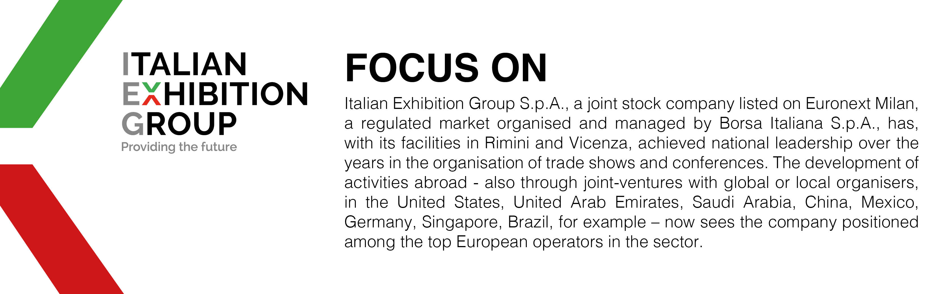

This press release contains forecast elements and estimates that reflect the management’s current opinions (“forward-looking statements”), particularly regarding future management performance, realization of investments, cash flow trends and the evolution of the financial structure. For their very nature, forward-looking statements have a component of risk and uncertainty, as they depend on the occurrence of future events. The effective results may differ (even significantly) from those announced, due to numerous factors, including, only by way of example: food service market and tourist flow trends in Italy, gold and jewellery market trends, green economy market trends; the evolution of raw material prices; general macroeconomic conditions; geopolitical factors and evolutions in the legislative framework. Moreover, the information contained in this release does not claim to be complete, and has not been verified by independent third parties. Forecasts, estimates and objectives contained herein are based on the information available to the Company as at the date of this release.

